01. Runnable 生命周期监听器
在 LangChain 中，除了在链执行时传递 config+callbacks 来对链进行监听，Runnable 还提供了一个简约的方法 with_listeners 来监听 开始、结束、出错 这 3 个常见的生命周期，并且 with_listeners 提供的方法比 CallbackHandler 更简洁，更统一。
with_listeners 配置的 on_start、on_end、on_error 函数格式参数一模一样，如下：
- run_obj: Run：运行时对象，内部涵盖了运行id、运行名称、开始时间、结束时间、运行类型、额外数据、错误信息、输入字典、输出字典、标签等内容。
- config: RunnableConfig：执行时传递的 config 配置信息，类型为字典。
例如，为 RunnableLambda 添加对应的生命周期监听器
import time

from langchain_core.runnables import RunnableLambda, RunnableConfig
from langchain_core.tracers.schemas import Run

def on_start(run_obj: Run, config: RunnableConfig) -> None:
print("on_start")
print("run_obj:", run_obj.inputs)
print("config:", config)
print("========================")

def on_end(run_obj: Run, config: RunnableConfig) -> None:
print("on_end")
print("run_obj:", run_obj)
print("config:", config)
print("========================")

def on_error(run_obj: Run, config: RunnableConfig) -> None:
print("on_error")
print("run_obj:", run_obj)
print("config:", config)
print("========================")

runnable = RunnableLambda(lambda x: time.sleep(x))
chain = runnable.with_listeners(on_start=on_start, on_end=on_end, on_error=on_error)

chain.invoke(2)
输出内容
on_start
run_obj: {'input': 2}
config: {'configurable': {'name': '慕小课'}}
========================
on_end
run_obj: id=UUID('3479d7ab-3bc7-4c4c-9db9-aaaff0c1fd04') name='RunnableLambda' start_time=datetime.datetime(2024, 7, 6, 9, 24, 52, 820817, tzinfo=datetime.timezone.utc) run_type='chain' end_time=datetime.datetime(2024, 7, 6, 9, 24, 54, 821575, tzinfo=datetime.timezone.utc) extra={'metadata': {'name': '慕小课'}} error=None serialized={'lc': 1, 'type': 'not_implemented', 'id': ['langchain_core', 'runnables', 'base', 'RunnableLambda'], 'repr': 'RunnableLambda(lambda x: time.sleep(x))'} events=[{'name': 'start', 'time': datetime.datetime(2024, 7, 6, 9, 24, 52, 820817, tzinfo=datetime.timezone.utc)}, {'name': 'end', 'time': datetime.datetime(2024, 7, 6, 9, 24, 54, 821575, tzinfo=datetime.timezone.utc)}] inputs={'input': 2} outputs={'output': None} reference_example_id=None parent_run_id=None tags=[] child_runs=[] trace_id=UUID('3479d7ab-3bc7-4c4c-9db9-aaaff0c1fd04') dotted_order='20240706T092452820817Z3479d7ab-3bc7-4c4c-9db9-aaaff0c1fd04'
config: {'configurable': {'name': '慕小课'}}
02. with_listeners 运行流程与解析
with_listeners() 在底层会将传递的 on_start、on_end 、on_error 合并到 config 配置选项汇中的 callbacks 中，本质上就是使用 CallbackHandler 的逻辑来实现对应的监听。
运行流程
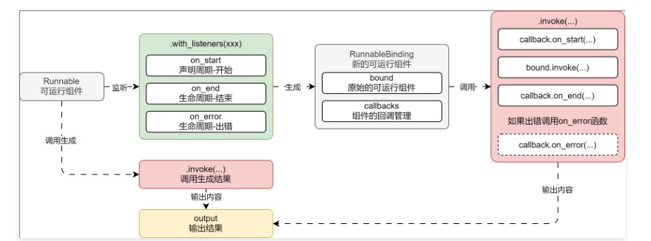
核心代码：
# langchain_core/runnables/base.py -> Runnable
def with_listeners(
self,
*,
on_start: Optional[
Union[Callable[[Run], None], Callable[[Run, RunnableConfig], None]]
] = None,
on_end: Optional[
Union[Callable[[Run], None], Callable[[Run, RunnableConfig], None]]
] = None,
on_error: Optional[
Union[Callable[[Run], None], Callable[[Run, RunnableConfig], None]]
] = None,
) -> Runnable[Input, Output]:
from langchain_core.tracers.root_listeners import RootListenersTracer

return RunnableBinding(
bound=self,
config_factories=[
lambda config: {
"callbacks": [
RootListenersTracer(
config=config,
on_start=on_start,
on_end=on_end,
on_error=on_error,
)
],
}
],
)
# langchain_core/runnables/base.py -> RunnableBindingBase
def _merge_configs(self, *configs: Optional[RunnableConfig]) -> RunnableConfig:
config = merge_configs(self.config, *configs)
return merge_configs(config, *(f(config) for f in self.config_factories))

